**C PROGRAMMING ASSIGNMENT:**

**5**

DATE: 29.10.21

SUBMITTED BY: -

NAME: MUKTESH MISHRA

BRANCH: CSE

SECTION: B22

ROLL NO.: 21052258

**Program 1:** Write a program to find distance travelled by an object.

Code:

#include<stdio.h>

#define g 9.8

int main(int argc, char const *argv[])

{

    int u,t,s;

    printf("Enter the initial velocity and time period \n");

    scanf("%d %d",&u,&t);

    s=(u*t)+(1/2.0)*g*t*t;

    printf("The ditance travelled by an object is %d meters",s);

    return 0;

}

Output:

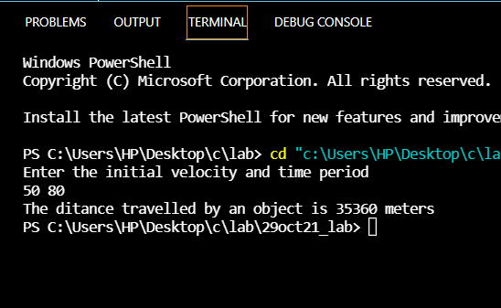

**Program 2:** Write a program to swap 2 numbers without using a third variable

Code:

#include<stdio.h>

int main(int argc, char const *argv[])

{

    int a,b;

    printf("Enter the 2 numbers to be swapped\n");

    scanf("%d %d",&a,&b);

    printf("\nValues before swapping: %d %d",a,b);

    a=a+b;

    b=a-b;

    a=a-b;

    printf("\nValues after swapping: %d %d",a,b);

    return 0;

}

Output:

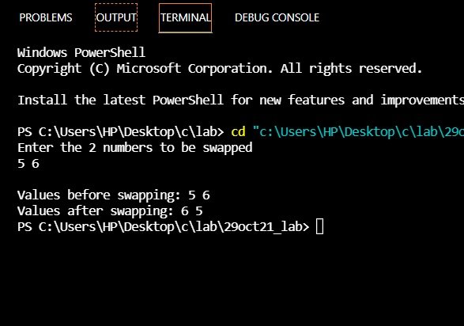

**Program 3**: Write a program to swap two numbers with using a third variable

Code:

#include <stdio.h>

int main()

{

int a,b, temp;

printf("Enter two integers\n");

scanf("%d %d", &a, &b);

printf("Before Swapping First variable = %d Second variable = %d\n", a, b);

temp = a;

a = b;

b = temp;

printf("After Swapping First variable = %d Second variable = %d\n", a, b);

return 0;

}

Output;

